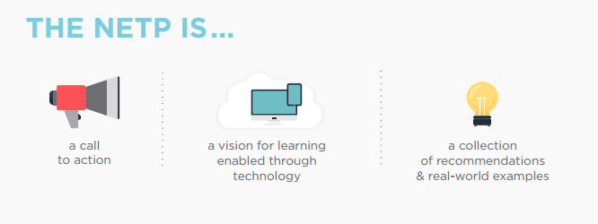

NETP Recommendations | Current reality at my school | What needs to happen at my school?
Future-Ready Learning:
- develop and implement learning resources that embody the flexibility and power of technology to create equitable and accessible learning ecosystems that make learning possible everywhere and all the time for all students
- take inventory of and align all learning technology resources to intended educational outcomes

Future-Ready Teaching:
- Provide educators with professional learning experiences powered by technology to increase their digital literacy and enable them to create compelling learning activities that improve learning and teaching, assessment, and instructional practices
- Use technology to provide all learners with online access to effective teaching and better learning opportunities with options in places where they are not otherwise available
Future-Ready Leading:
- Set a vision for the use of technology to enable learning for students, educators, families, technology professionals, community groups, cultural institutions, and other interested parties
- Develop clear communities of practice for education leaders at all levels that act as a hub for setting vision, understanding research, and sharing practices

Future-Ready Assessing:
- design, develop, and implement learning dashboards, response systems, and communication pathways that provide timely and actionable feedback about student learning to improve achievement and instructional practices
- explore how embedded assessment technologies such as simulations, collaboration environments, virtual worlds, games, and cognitive tutors can be used to engage and motivate learners while assessing complex skills

Future-Ready Infrastructure:
- High-speed connectivity to schools
- Data Privacy and security
- High-speed wifi throughout schools
- High-quality, low-cost devices
- Home internet access
- Digital citizenship and responsible us
- Quality digital content and resources

Access the full report: https://tech.ed.gov/files/2017/01/NETP17.pdf

