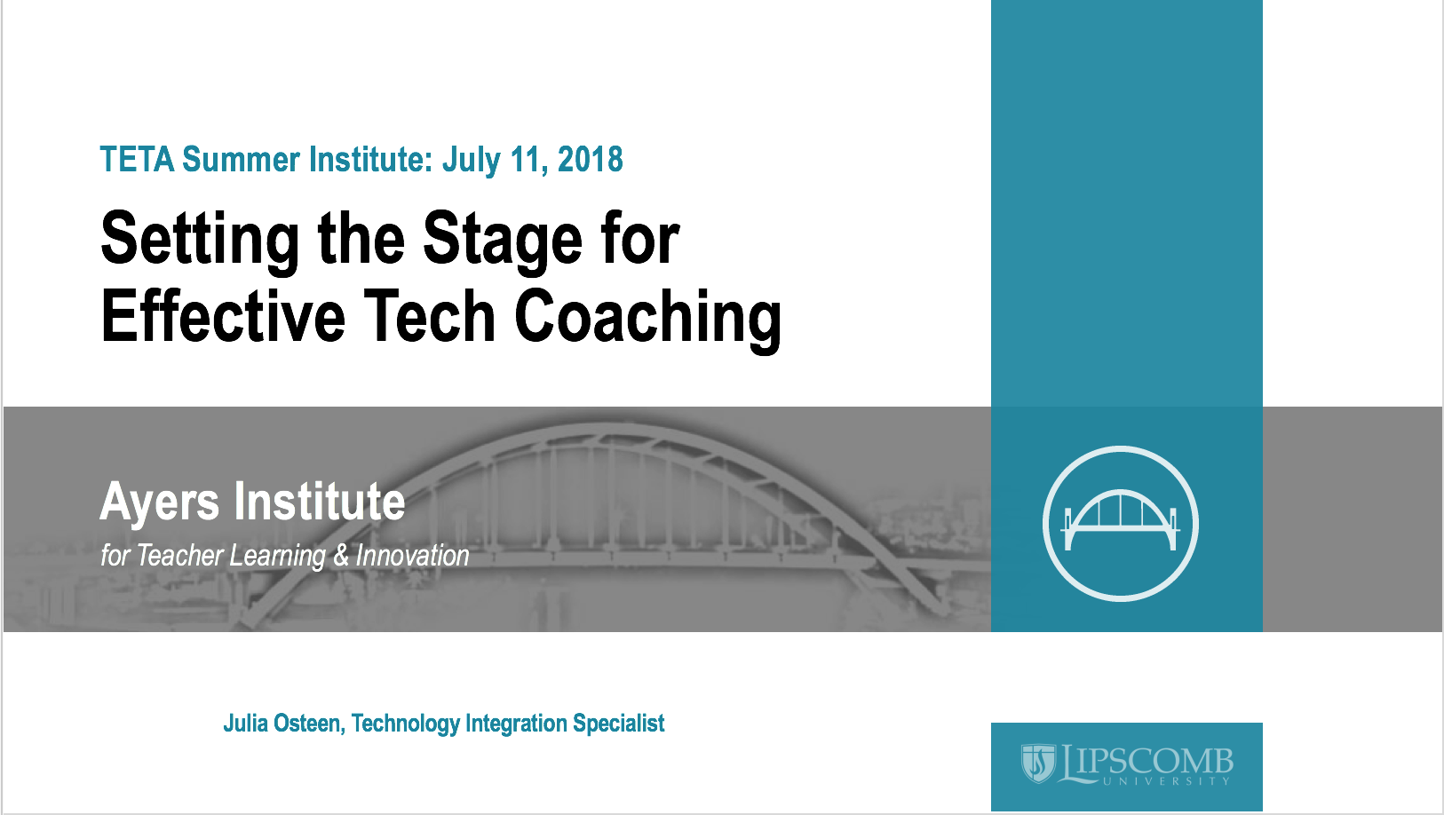
Presenter: Julia Osteen, Technology Integration Specialist, Ayers Institute for Teacher Learning & Innovation at Lipscomb University, julia.osteen@lipscomb.edu

Session description: The ISTE Standards for Coaches provide needed guidance for tech coaches when it comes to the areas of instructional technology with which coaches need to provide leadership. But how do you begin a coaching relationship with a teacher? What needs to be considered? What’s the role of school leaders with tech coaching? Join us as we delve into these questions and more. This session is designed with technology coaches, teacher leaders, and school leaders in mind.
Session link: https://edutoolbox.org/node/490

Session notes:
Key points:

ISTE Standards for Coaches
___________________________________________________________________________________________________________________________________________________________________________________________________________________________________________________________________________________________________________________________________________________________________________________________________________________________________________________

What is a coach?

David Rock’s SCARF Model
Status
Certainty
Autonomy
Relatedness
Fairness

Coaching Skill: Presuming Positive Intent
Language habits of mind
Creates an environment of trust and respect

Role with technology coaching
Coaches
Teachers
School leaders

Reflection

Session resources:
Padlet – https://padlet.com/julia_osteen1/tetasi2018

ISTE Standards for Coaches - https://www.iste.org/standards/for-coaches

Why Don’t Educators Want to be Coached? –
http://blogs.edweek.org/edweek/finding_common_ground/2016/08/why_dont_educators_want_to_be_coached.html

Effective Digital Learning Environments - https://www.iste.org/resources/product?id=3732

Ayers Institute Instructional Coaching Academy: Skills Development - https://tinyurl.com/july2018coachingacademy

Ayers Institute Instructional Coaching Academy: Models and Practices - https://tinyurl.com/sept2018coachingacademy

Lipscomb University College of Education Graduate Programs - https://www.lipscomb.edu/education/graduate-programs

References:

Barth, R. (2006, March). “Improving relationships within the schoolhouse.” Educational Leadership.
63(6). Retrieved from http://www.ascd.org/publications/educational-
leadership/mar06/vol63/num06/Improving-Relationships-Within-the-Schoolhouse.aspx

DeWitt, P. (2016, August 08). Why Don't Educators Want to Be Coached? Retrieved July 8, 2018, from
http://blogs.edweek.org/edweek/finding_common_ground/2016/08/why_dont_educators_wa
nt_to_be_coached.html

ISTE Standards. (2011). ISTE standards for coaches. Retrieved from
https://www.iste.org/standards/standards/standards-for-coaches

Kee, K.M. & Anderson, K.A. (2010). RESULTS coaching: the new essential for school leaders. Thousand
Oaks, CA: Corwin.

Knight, J. (2007). Instructional coaching: a partnership approach. Thousand Oaks, CA: Corwin.

Rock, D. (2008) “SCARF: A brain-based model for collaborating with and influencing others.”
NeuroLeadership Journal. Retrieved: www.Neuroleadership.org

