Basic TinkerCAD Controls

UNDO

1. Select the object or action, click (ctrl + z) or undo

2. Ungroup (ctrl + Shift + G) undoes the grouping.
Camera Controls  To look at all sides of the object, you’ll use the camera controls (cube) to change your view around the shape.  Leave in perspective view to keep a true view of the object. | 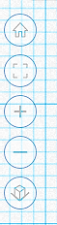  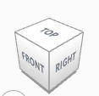  Home  Fit to Screen  Zoom In  Zoom Out  Orthographic /  Perspective view
Ruler  Use to measure and place objects.  ALL MEAUSREMENTS IN mm! | 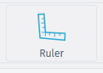  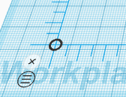
To Change Size  1. Grab the white corner handle, left click & drag.  2. Drop the ruler, select the dimension and type it in. | 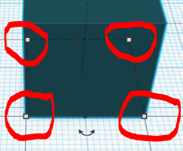  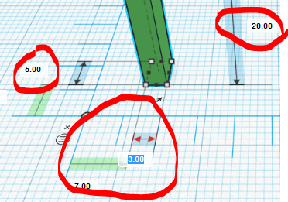
To Make a Centered Hole  1. Select a solid and the hole shape you want in it.  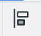  2. Select both objects (highlight or shift + left click), select the align tool. (L)  3. Press the center buttons.  4. Select both again, then select group. (ctrl + G) | 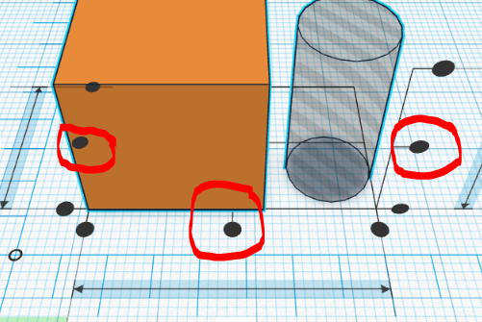  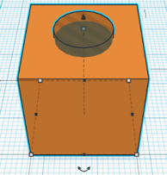  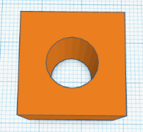
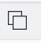  To Copy & Paste  1. Left click on object to select.  2. Ctrl + C to copy.  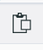  3. Ctrl + V to Paste. | 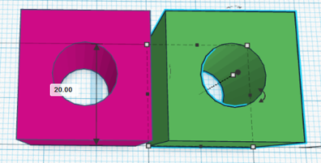
To Rotate  1. Left click on object to select.  2. Select the double arrow. Hold shift to rotate 45 degrees at a time. | 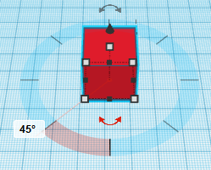  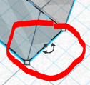
To Array (Repeat around a Point)  1. Select object, then Ctrl + D to duplicate in place.  2. Rotate the second object where wanted.  3. Repeat Ctrl + D to duplicate into a full circle. | 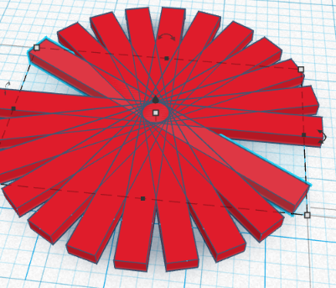  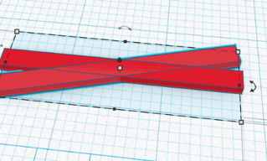
To Make a Mirior Object  1. Copy & Paste. (ctrl + C, ctrl + V)  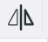  2. Use the flip tool (M) to mirror on each axis. | 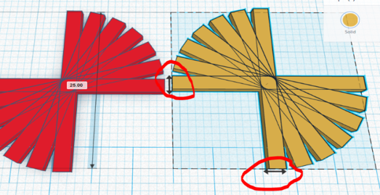
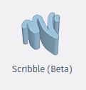  Freehand draw (Scribble)  This feature is in Beta testing, so there may be changes. Click the Done button to place it on the build plane. | 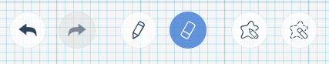  Undo Redo Brush Erase Draw Erase  Shape Shape
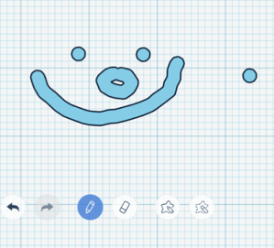
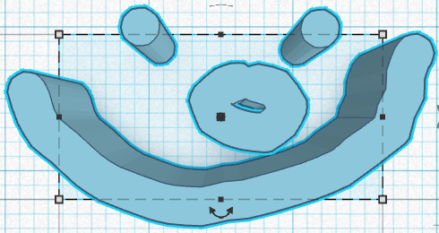
Exporting for 3D Printing  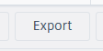  1. To 3D print, select the object you want, and use the export button to download.  2. Save as .stl for 3D printing. For laser cutting use .svg.  3. Take the file to a 3D printer, public library, or 3Dhubs to 3D print. | 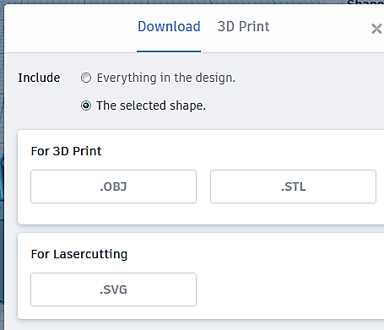

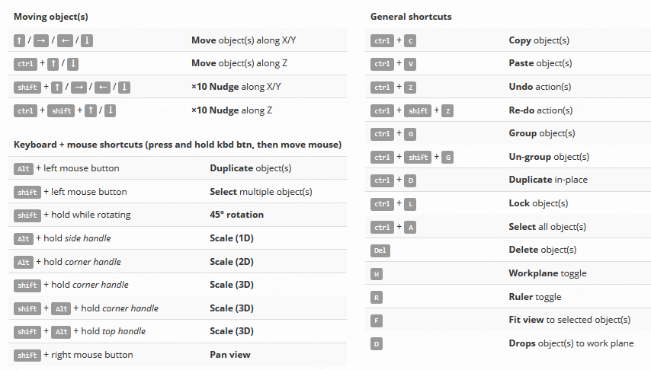

Advanced TinkerCAD Controls

Import  You can import and modify other .stl or .svg models.  This is handy for file repairs, modifications, or adding logos and text.  Watch scaling as you import and export. | 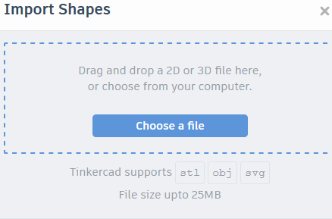
Importing Graphics  You can convert .jpeg or .png graphics to .stl using a free graphics converter.  https://image.online-convert.com/convert-to-svg  Original (L) Owl logo, Converted .stl file (R) from http://options.cherrycreekschools.org  /Pages/default.aspx | 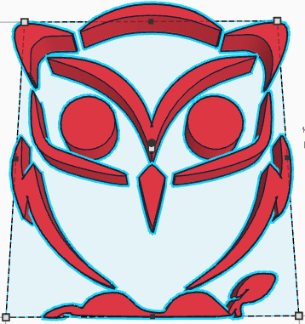
Other Features  Minecraft Blocks: Build worlds in Minecraft and export to your server.  Lego Bricks: Convert a design into Lego bricks. If your design is smaller than the dimensions of Lego bricks, they will not show in the Lego build plate.  Shape Generator: A.K.A. Parametric generator. This function lets you build a repeatable geometry that you can modify easily.  You can also share this publically. | 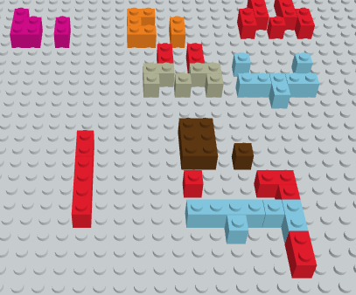  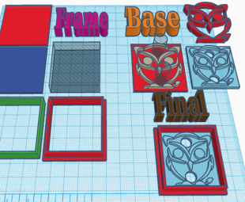  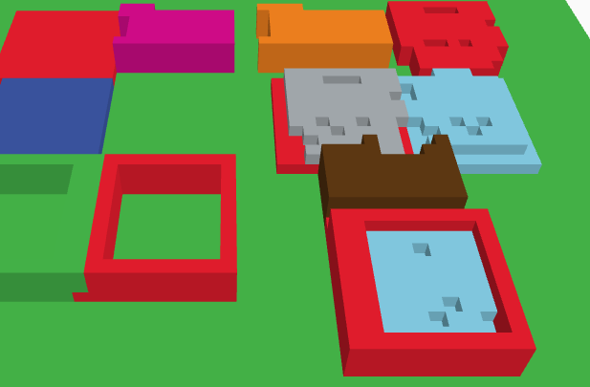  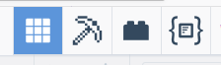

Circuits
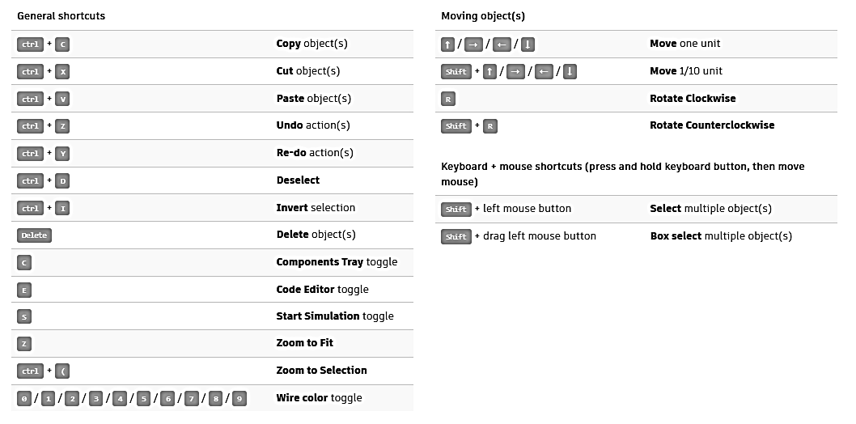

Assemblies  Follow the tutorials to build basic electronic assemblies. These are 3D printable and will require external hardware (wire, motors, LED’s, etc)  You can use these to build basic electronics into any object. It may be possible to print semi-conductive filament into the object, reducing wiring. | 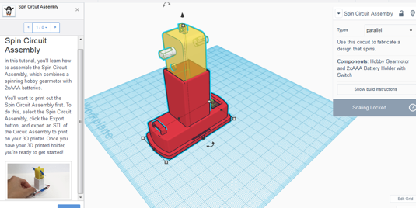
Microcomputers  (Raspberry Pi, Arduino Uno R3)  Follow the tutorials to assemble a microcomputer and integrate it into your object. You can also simulate and test programing. You can build simple computers or run machines with a microcomputer. | 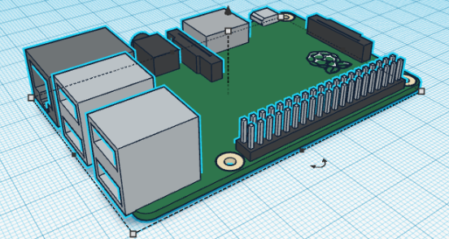
Breadboard  Prototype electronics with a virtual breadboard. Test your circuits and configuration here, then integrate them into your object. | 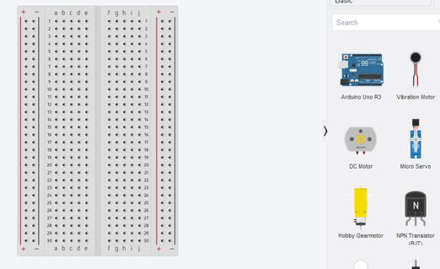
3D Printing Considerations for Fused Deposition Modeling (FDM) printing.

Overhangs  Anything over 45⁰ from vertical will need supports to print smoothly.  30⁰ – 45⁰ may print rough based on printer and material. | 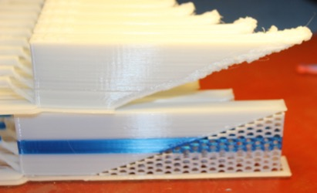
Bridges  Bridges may be unsupported from 10 - 30 mm, but will need supports after to prevent drooping. | 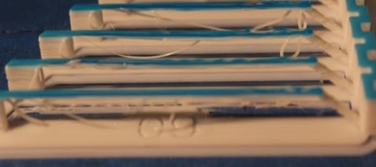
Supports  Supports can hold up overhangs and delicate parts. (HATY)  They will take more material to print, and may leave a rough surface that you will have to trim and sand (post processing) after the print is done.  If you have dual extrusion, you can use dissolving material (PVA) for supports. | 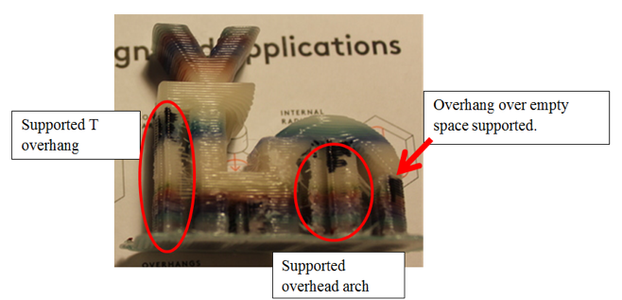
Bed Adhesion  If possible orient the largest, flattest side to the build plate and print without bed adhesion.  If you have sharp corners or round corners, use a skirt/brim.  Rafts are the last option as they use the most material and may be hard to remove. | 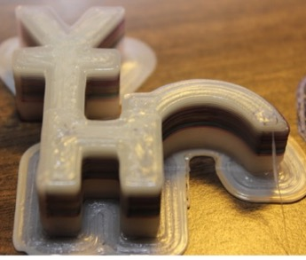  Brim keeping sharp corners  On build plate.
Shell  The thickness of the print wall (shell) is determined by the use of your object and the nozzle orifice diameter. 2-3 shells will suffice for many applications.  More shells can be used for heavy-duty applications or when there will be secondary hardware (screws, rods, etc.) added. | Thin shells (1-2) are good for transparent items or flexible materials. | Medium (2-4) shells are good for all general purpose prints. | Thick (4-solid) shells are good for complex shapes, or when hardware is installed.
Infill  High stress parts may need heavy infill, but the print time will increase. 10-20% will work if you have a complex shape.  Combine with orientation to minimize infill usage. | 0 % is good for flexible items and transparent prints. | 5% - 20 % is good for general shapes with a top. | > 50 % will add a lot of weight and print time, will be good for heavy duty applications
Orientation  3D prints on FDM printers do have a grain like wood, so take that into consideration if your object has stresses on an axis.  By changing the orientation, you can eliminate the need for supports, and give a cleaner appearance to your print. | Figure 1. Haty on L printed verticaly, while the Haty on right was printed horizontaly  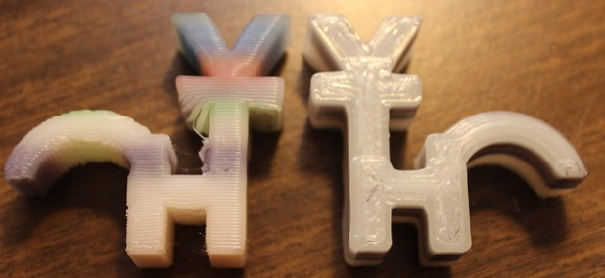

Advanced Modeling Methods
Dual Extrusion  With a dual extrusion (2 or more print heads) you can print multiple colors or materials (ridged and flexible) in one solid print.  To do this, you can export the two colors as different files (A / B) or .VRML format.  Dual extrusion can also print complex shapes that require support in dissolvable (PVA) filament. This tends to be a smoother print. | 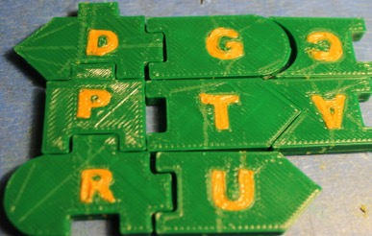  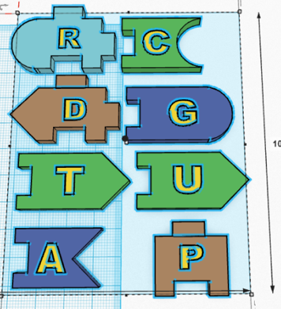
Print over fabric  You can print flexible or ridged material over fabric.  This can be useful for cosplay costumes, medical devices, or hardware attachment.  You can offset the Z axis by the thickness of the fabric in your design, or offset the distance on the build plate. | 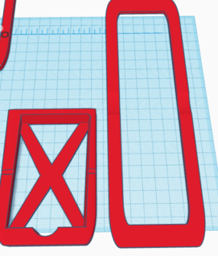  WARNING  IF YOU PRINT OVER FABRIC, AVOID SYNTHETICS THAT HAVE THE SAME PRINTING TEMPRATURE AS YOUR FILAMENT. COTTON, WOOL, OR OTHER HIGH TEMP FABRICS RECOMMENDED.

