How to Create a Developmentally Appropriate Daily Schedule:

A developmentally appropriate daily schedule should have the following characteristics:
- Schedule is located in a convenient space.
- The schedule should have visual and text clues.
- The schedule should be able to be manipulated or changed.
- Students should participate in the daily schedule monitoring.

Location of Daily Schedule:
- It is recommended to place the schedule near your large group meeting area so that it can be referenced throughout the day. The schedule should be placed at children’s eye level.
- For adult visitors of your classroom, you can post a typed adult friendly schedule on a wall at adult eye level.

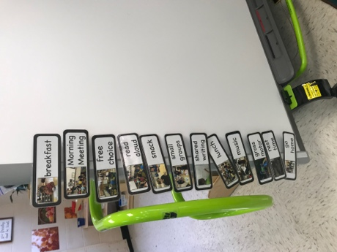  Child-friendly schedule is located near the group rug on the smartboard.  Classroom: Krista Ann Sumner, MNPS | 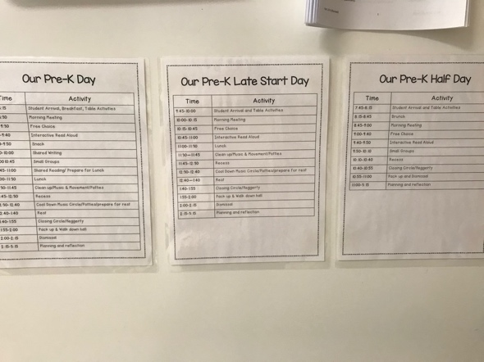  This teacher posts her adult friendly schedule near the door for visitors.  Classroom: Krista Ann Sumner, MNPS
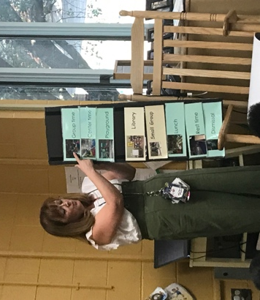  This teacher uses a portable board at the carpet for large group time.  Classroom: Stephanie Kirby, MNPS | 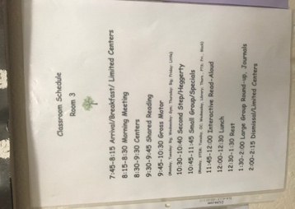  Ms. Kirby’s adult-friendly schedule is posted for visitors.  Classroom: Stephanie Kirby, MNPS

What does the schedule look like?
- Teachers can choose if they would like their schedule to be displayed vertically or horizontally. When using a horizontal schedule, you give students another opportunity to practice left to right print concepts.
- Teachers can choose which type of visual to use. The visuals should be accompanied by text. See below for options:
Real classroom photos and text  Classroom: Krista Ann Sumner, MNPS | - 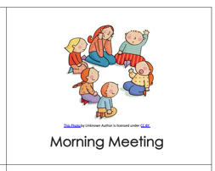  Clip art and text  Source: Josephine Appleby
- stock photo and text | - hand-drawn image and text (student writing or teacher writing)

How do I keep my schedule updated with the different parts of our day?
- In a school setting, you may have special visitors or occasions that come up to interrupt the consistency of a typical school day. Some students may get upset or feel anxious about an unprecedented change. A flexible classroom daily schedule can help students process and prepare for interruptions or change. The schedule should be flexible so that cards can be switched out when necessary. A flexible schedule allows students to still have the consistency of the schedule to rely on even where this is an “odd” day.

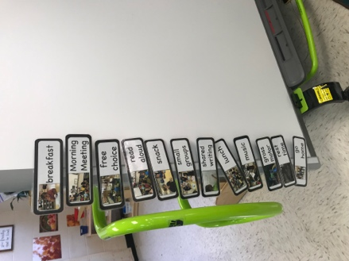  A Velcro strip is a great way to switch schedule cards in and out.  Classroom: Krista Ann Sumner, MNPS | Other ideas for a flexible schedule:  - Pocket chart and cards  - Clothes pins and cards  - Magnetic schedule on a whiteboard.  - Felt Schedule

How can students participate in monitoring the daily schedule?
- The schedule should have some sort of tracking ability so that students know what part of the day is occurring and what they have accomplished.
- The classroom can have a “schedule monitor”. This is a great job for that student who is always asking when recess is or has anxiety about the school day. It is also a great job to rotate and allow all students to have.

Ms. Harris has a student helper move a red arrow on felt to keep track of which part of the day is occurring.  Classroom: Briana Harris, MNPS | Ms. Kirby has a student remove a card from the schedule when it is complete. In this photo, the class has finished breakfast, so you the breakfast card is gone.  Classroom: Stephanie Kirby, MNPS
Other ideas for tracking the day:
- Clothes pin
- Special magnet

