Child’s Name__________________________________

Note: Mark the highest category when the child generates mixed response.
Writing Form: What the Child’s Writing Looks Like
Level | Category | Example | Date | Date | Date | Date | Date | Date
0 | No marks
1 | Drawing only | Child draws a picture instead of writing
2 | Scribbles | 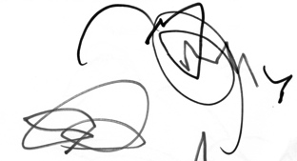
3 | Scribble units
4 | Individual stroke units | 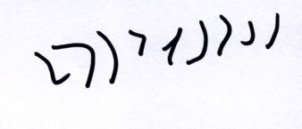
5 | Personal Manuscript  (letter like forms) | 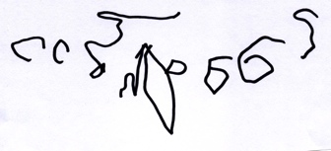
 | Personal Cursive | 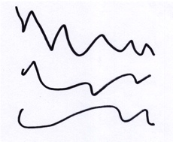
6 | Conventional letters plus letter like forms | 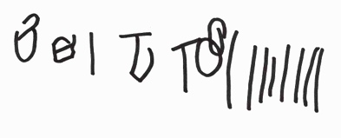  (reversals are OK)
7 | Conventional letters  (no letter-sound correspondence) | 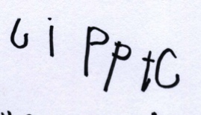  ”Go slow”
8 | Conventional Letters in  Memorized Word | Writes his/her name.  Writes: I Love You.
9 | Invented spelling  (Semi-phonetic)  First Letter sound, or one sound to represent a word | silver  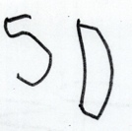  dollar
10 | Invented Spelling  (Semi-phonetic)  First & last | 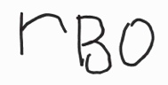  “rainbow”
11 | Invented Spelling  (Phonetic)  Most Sounds represented | 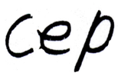  “ship”
12 | Transitional Spelling | Visual, meaning-based, orthographic patterns  BOTE for boat  THAY for they

Speech/Print Matching (Intentionality)
Level | Category  Score child’s response to: “Read it to me!” | Example | Date | Date | Date | Date | Date | Date
1 | Marks not Read
2 | Sign Concept: | Asks adult: What did I write?
3 | Reads without Speech/Print Match: | Reads message with normal speech speed and rhythm, but does not indicate how the message links to marks on the page
4 | Natural Speech/General Pointing: | Reads marks with natural speech speed and rhythm; points in a general way to the marks on the page (no specific matching of marks to speech segments)
5 | Segmented Speech/General Pointing: | Reads marks by slowing and segmenting spoken message in a way that does not sound like natural speech; Points in a general way to the marks on the page (no specific matching of marks to speech)
6 | Matches Whole Words/Phrases to Marks: | Slows and segments spoken message into words or phrases; Points to or writes marks in rhythm with the spoken segments
7 | Matches Sounds to Marks/Letters: | Slows and segments a word into (some) individual sounds; Matches the sound to a specific mark or letter.

Task/Message Match (Message Content)
Level | Category  Score child’s oral reading of the message. | Example | Date | Date | Date | Date | Date | Date
0 | No Marks or Does not read message
1 | Message unrelated to topic or task
2 | Message unrelated: Other conventional message | “I Love You”  “A, B, C,D”  Names of family/friends (not pictured)
3 | Message has general relation to Writing Materials, Processes, Purposes | “It’s red.” To describe marker color.  “It’s for you. I’m gonna take it home.”  “I went around and around.” To describe use of pen.
4 | Message has general relation to topic | “It’s about dinosaurs.”
5 | Writes a word as label related to topic | Writes “bike” when a bike is pictured in the drawing
6 | Writes a multi-word phrase related to topic | Writes “my new shoes” when illustration shows child and shoes.
7 | Writes a sentence related to topic | Writes a complete sentence related to the topic.

Directionality
Level | Category | Example | Date | Date | Date | Date | Date | Date
0 | No Marks; A single dot/letter, scribble; Draws Picture
1 | Random placement of multiple units, forms, or letters
2 | Unconventional Linear | Right to Left; Bottom to Top
3 | Conventional Linear for Line 1, then unconventional | Left to Right for Line 1; Then unconventional directional placement
4 | Conventional All Lines

Reference: Rowe, D. W., & Wilson, S. (2015). The development of a descriptive measure of early childhood writing: Results from the Write Start! Writing Assessment. Journal of Literacy Research, 47(2), 245-292. doi: 10.1177/1086296X15619723.

